PIC Based Digital Alarm Clock

Introduction

Digital Alarm Clocks are no longer news. They have been around for years now but, still, most of the present off-the-shelf products have some design limitations.

Many don’t keep track of week days.

In general, they store only one alarm time.
This is a serious limitation if, for instance, you and your wife have got different wake-up times or if you have to take, or give someone else, medicines at regular intervals.
This limitation gets more serious if you want alarms to go off only on specific days of the week or only during work days.

The time setting process has also opportunities for improvement.
In the great majority you adjust time incrementing minutes and hours. If your clock is at, let’s say, 06:15 and the correct time is 20:58 you’ve got a long way ahead pressing the incrementing key and, if you pass through the right hour/minute, you’ll have to start it all over again.

This project brings a solution for these design weaknesses with a low cost circuit based on the popular PIC 16F84A microcontroller from Microchip. The hardware described here will also work with the PIC 16F628 provided that the firmware be adapted to this microcontroller which, also is available. The appendix A of this article describes the additional features the 16F628 version contains.

This digital alarm clock keeps track of week days and has 8 alarms that can be individually set to go off every day, only on work days or, if you will, on a specific day of the week.

The time setting process allows the adjustment of each digit of the clock separately by means of Up and Down keys.

It also incorporates some other interesting characteristics:

- Like all good digital alarm clocks it has a battery that holds the circuit on in the event of an AC power outage.
- In the battery mode the display is turned off to reduce energy consumption but, if you want to check the time you may light it up pressing a “display on” key.
- In the battery mode the alarms will operate normally. When an alarm goes off the display will be turned on to show the current time.
- The 8 different alarm setups are kept in the PIC eeprom. This means that, even if you loose the battery, you won’t have to adjust all alarms again.
- A “snooze” key will temporarily turn an alarm off. The alarm will be triggered in the next minute until it’s definitely turned off.
- A master Alarm On/Off key will enable/disable all the alarms independently of their individually set states.
- A bright LED display makes it easy to check the time from distance or in the dark.
- The 4MHz crystal oscillator guarantees a very precise time base for the clock (error = 0.000427%).
The Hardware

The figure below shows the clock’s complete circuit.

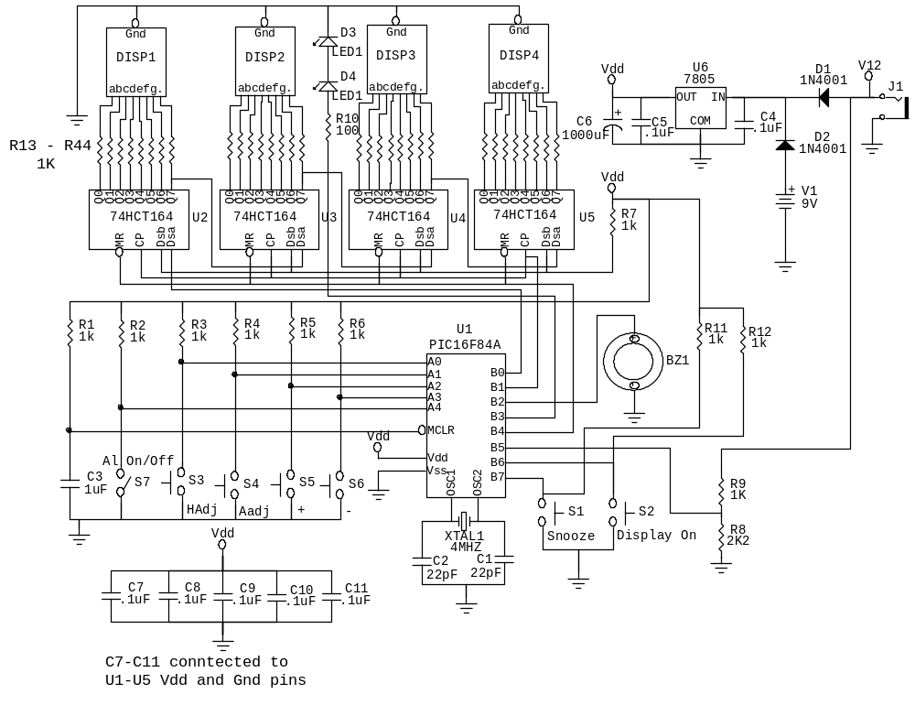

Fig.1

The heart of the circuit is the PIC16F84A microcontroller from Microchip.

XTAL1 with C1 and C2 form the resonant circuit of the microcontroller oscillator which operates at 4MHz.

R1 and C3 guarantee that the microcontroller is reset at power-on.

Switches S3 to S7 are connected to the microcontroller’s PORTA pins (all configured as inputs). R2 to R5 guarantee a HIGH logic level at the PORTA pins when the switches are open.
When closed, these keys will force a LOW state in the PORTA pin which they are connected to triggering the execution of specific clock control routines described in the Software section of this document.

PORTB.6 and PORTB.7 are configured as inputs.
R11 and R12 guarantee a HIGH logic level at each input when the S1 and S2 are open.
S1, when closed, will activate the “Snooze” function.
S2, when closed, will temporarily activate the display. This function is only available when the clock is operating in the battery mode.

R8 and R9 form a voltage divider fed by the main 12VDC source. They guarantee a HIGH logic level at PORTB.5 when the main power is available. In this situation the display will be permanently on. If, for some reason the main power is not available (AC power outage) there will be a LOW logic level at PORTB.5 and the display will be turned off.

The alarm beeper BZ1 is connected to PORTB.2.

PORTB.3 controls LED1 and LED2 which are the display Hour/Minute separator.

Four Common Catode 7-Segment displays, DISP1 to DISP4 constitute the visual interface of the clock.
These displays are driven by four 74HCT164 shift registers (U2 to U5) connected in series.

R7 just guarantees a HIGH level to the ENABLE pins of the shift registers.

PORTB.1 drives the CLOCK (pin8) of the shift registers while PORTB.0 drives the DATA line of the first shift register (U2, pin1).
The microcontroller program will clock in 32-bit strings into the shift registers whenever a display update is necessary.

PORTB.4 controls the RESET pin of the shift registers. This port will be held LOW when the display is to be turned off.

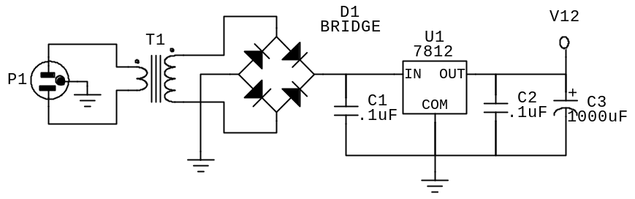
The regular 12VDC power may be supplied by a standard AC/DC adapter. Another option is to incorporate
the circuit shown below to the project (of course that will demand a different PCB layout and a bigger case to host the entire circuit).

Fig.2

Back to the main circuit, diodes D1 and D2 will guarantee exclusive operation of either the 9V battery or the 12VDC power source. They will also guarantee that R8 and R9 be powered only by the 12VDC source.

The 5VDC, necessary to feed the logic circuit, is provided by a 7805 regulator. C4, C5 and C6 guarantee appropriate filtering of undesirable noise/harmonics.
Below you have the material list not including the power supply shown in Fig.2:

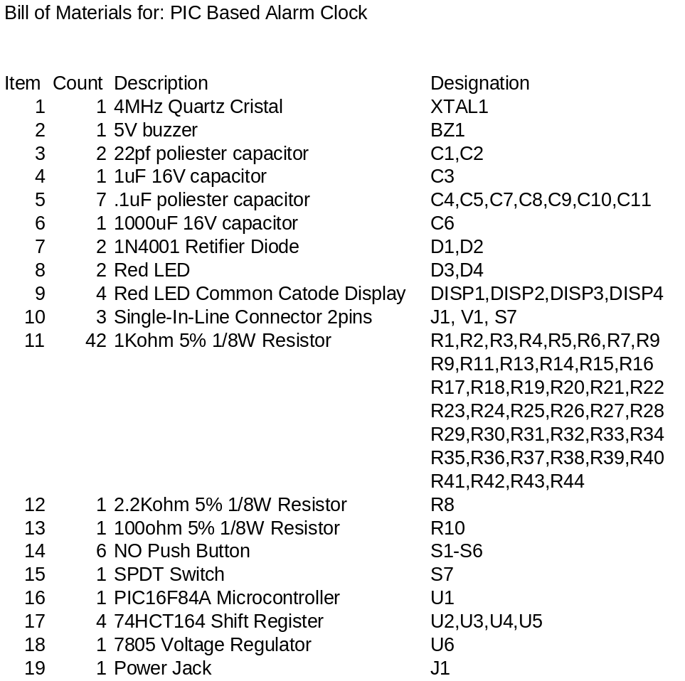

On pages 5 and 6 you’ll find pictures of the PCB’s layout as well as of the alarm clock after assembly. Gerber files and mechanical drawings can be supplied by the author for those interested.

Some PCB assembly tips:

Start by soldering the connectors, IC sockets and switches (if they are to be soldered directly to the the PCB). It is recommended that all integrated circuits (microcontroller and shift registers) be mounted on sockets and not soldered directly to the PCB. Not mandatory but a good practice would be to have the displays mounted on single-in-line bars instead of being soldered directly to the PCB.

After that, solder the passive components like resistors and capacitors. Once you are done with them solder the rectifiers, LED’s and voltage regulator. Take care with the polarity of electrolytic capacitors and diodes.

Clean up the assembly with alcohol in order to remove solder flux residues.

With a multimeter make sure that there’s no short circuits between power and ground.

When loading the integrated circuits and displays check the correct “pin 1’ position.

Avoid ESD damages to your circuit by keeping yourself grounded by means of adequate wrist straps.

PCB Layout:
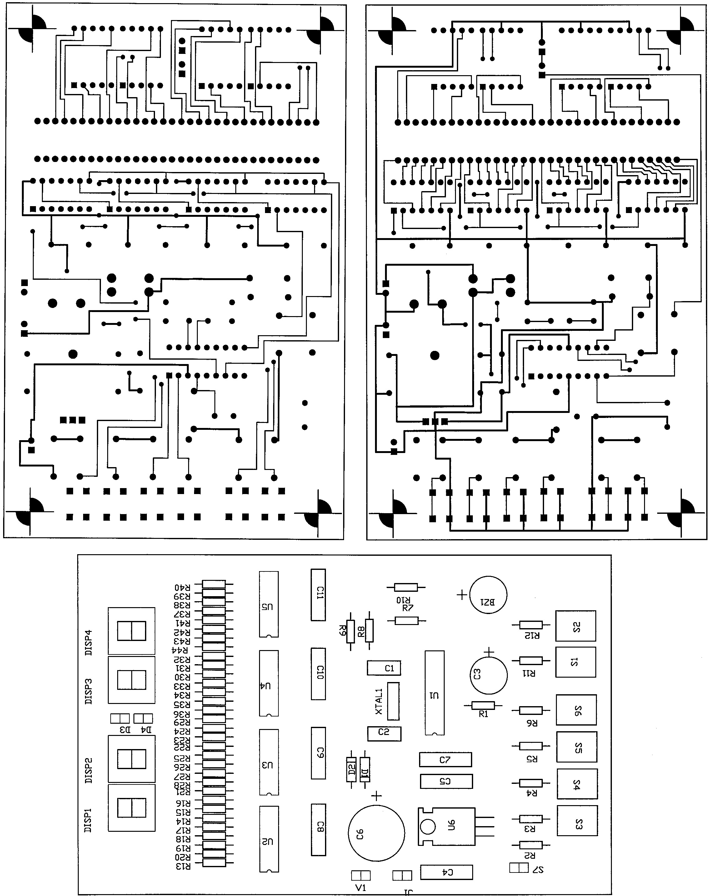
Bottom Layer
Top Layer
Top Overlay
Fig. 3
Alarm Clock Assembly

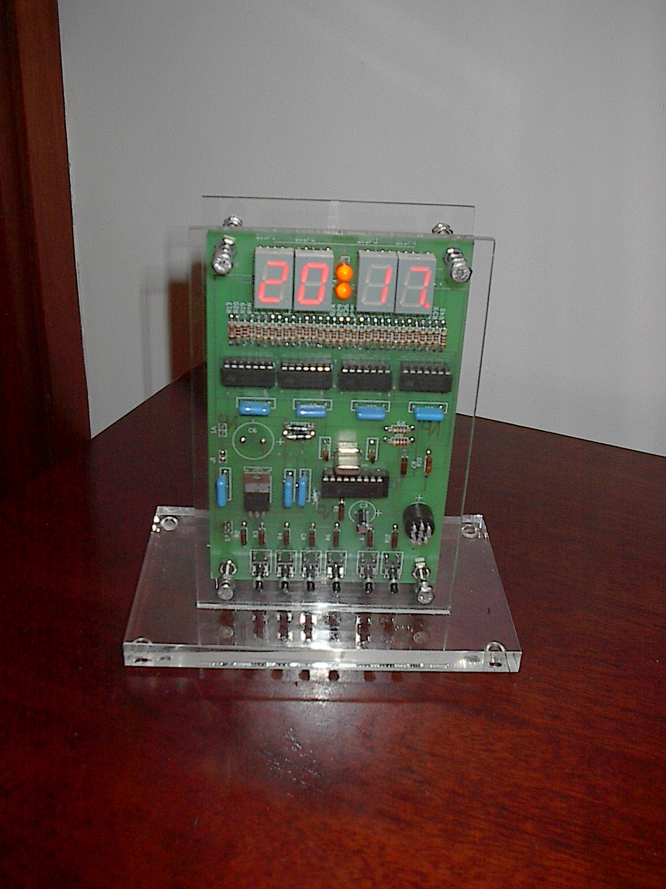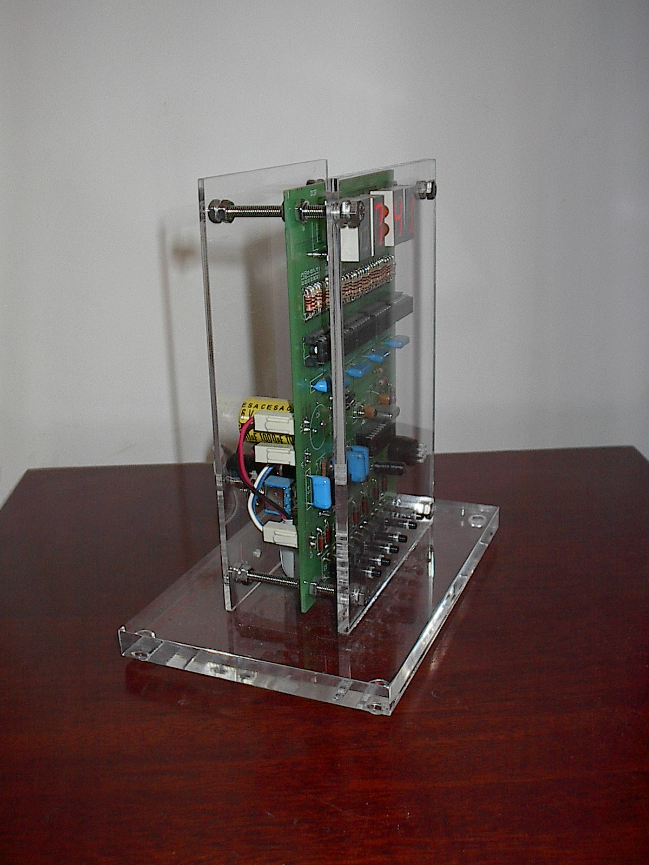

Fig. 4
The Software

The entire clock program was written in the PIC Assembly Language using the MPLAB Integrated Development Environment version 5.70.40 supplied by Microchip free of charge.

The Source Code and HEX files containing the program ready to be flashed into the PIC microcontroller is supplied free of charge by the author for those that are interested in.

The flowchart below summarizes the operation of the program.

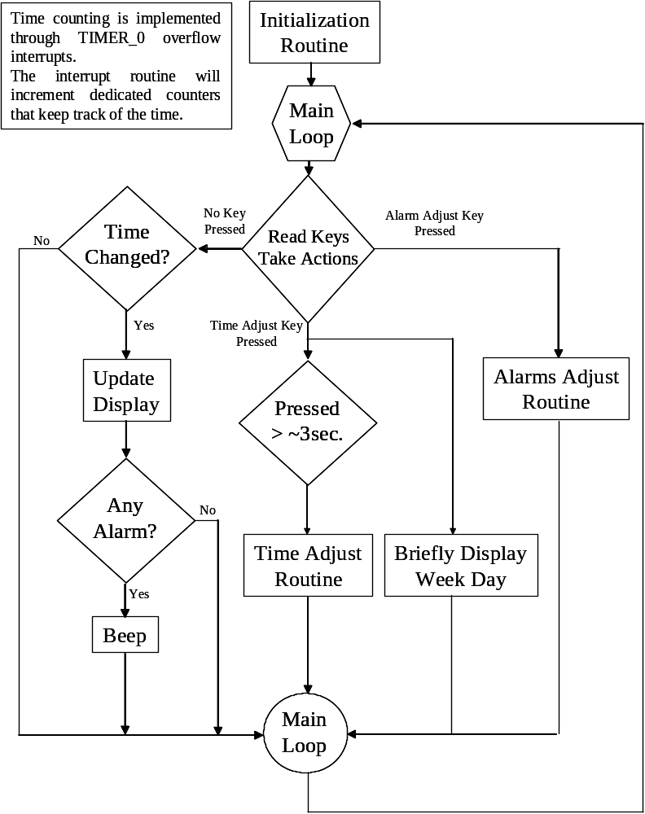

Fig.5

After an initialization routine where I/O pins, Interrupt register, Timer_0/Prescaler operation are configured and alarms information is read from the eeprom into the data memory, the program enters a loop in which control keys are read and, based on their status, a specific branch is taken.

So, if the Alarm Adjust Key is pressed and hold down for a period of more than ~3 sec. the program will execute the Alarm Adjust Routine and, once finished, return to the main loop.

If the Time Adjust Key is pressed for a short period (less than ~3 sec.) the display will show the current Week Day.

If the key remains pressed and hold down for a period of more than ~3 sec. the program will execute the Time Adjust Routine and, once time and week day are adjusted, return to the main loop.

While no key is pressed the program keeps checking whether time has changed, updating the display, checking the alarms and triggering the beeper if required.

Although it has not been detailed in this summarized flowchart, the display updating process is affected by the status of the PORTB.5 (12VDC power availability) while the alarm verification and triggering processes are subject to the status of Alarm On/Off and Snooze Keys.

In the Operation Section of this document you’ll get the details on how to use the keys to set and control the clock.

One important piece of the software is the time counting process.

It is based on the microcontroller TIMER_0 which has the ability to interrupt the main program and deviate its execution to an interrupt handling routine whenever its count overflows (FFh -> 00h).

The microcontroller is configured so that the TIMER_0 overflow will take place every 2.048mS (this is accomplished setting the Prescaler to divide the TIMER_0 clock by 8).

The interrupt handling routine, whenever called, will increment a 16-bit counter. This counter has a maximum count of 29297 (7271h). This means that every minute (29297 x 2.048mS = 60,000,256 mS which is very close to 1 minute) it will overflow.

The overflow of the 16-bit counter increments the minute-counter (module 10) which, after overflowing, increments the tens-of-minute counter (module 6) which increments the hour-counter which finally increment the tens-of-hour counter.

As shown above, the clock’s minute is slightly longer than it should be (60.000256 sec. x 60 sec.).
This error (0.000427%) will generate a time difference of less than 2 minutes per year. This error is pretty low compared to what is presented by most the off-the-shelf clocks.
The Clock Operation

The following figures and diagrams describe in more details:

- The clock’s display
- The clock’s keys and their functions
- The Alarm On/Off key operation
- The Beeper Control procedure
- The operation under Battery Mode (mains power failure)
- The Time Adjustment process
- The Alarms Adjustment proces

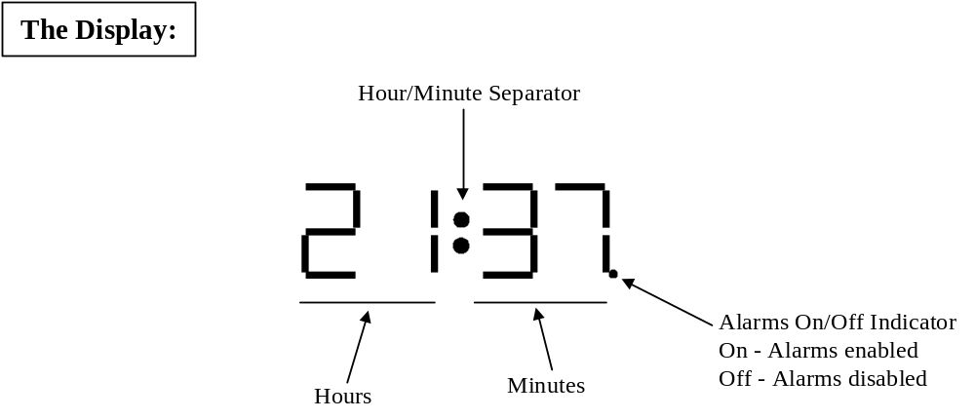

Fig.4



Fig. 6

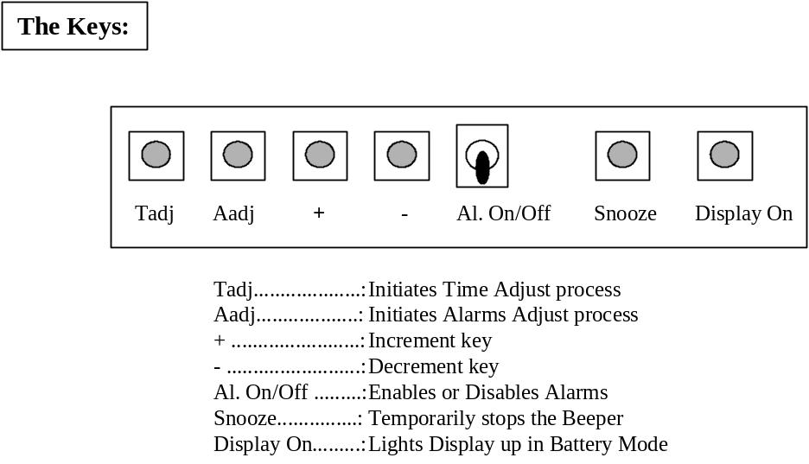
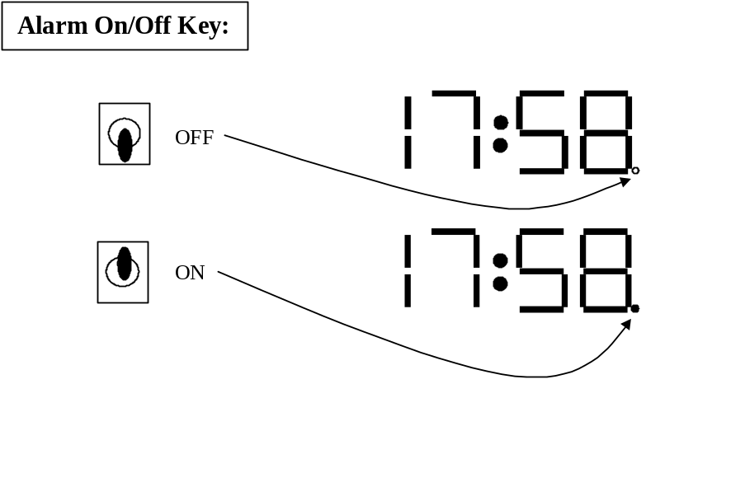Fig.7

Fig. 8

Remarks:
- If this key is OFF, no Alarms will be triggered regardless of their individual setups.
- This key will not stop the beeper after an alarm has gone off. In order to stop the beeper you have to press either Snooze or Aadj (see Beeper Control).

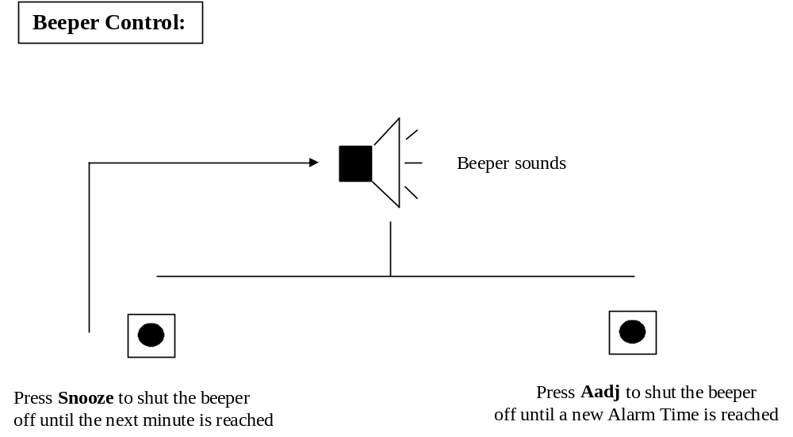

Fig.9

Remarks:
- Alarms verification and triggering will operate normally under battery mode.
- If Snooze or Aadj Keys are NOT pressed beeper will remain on until next minute.
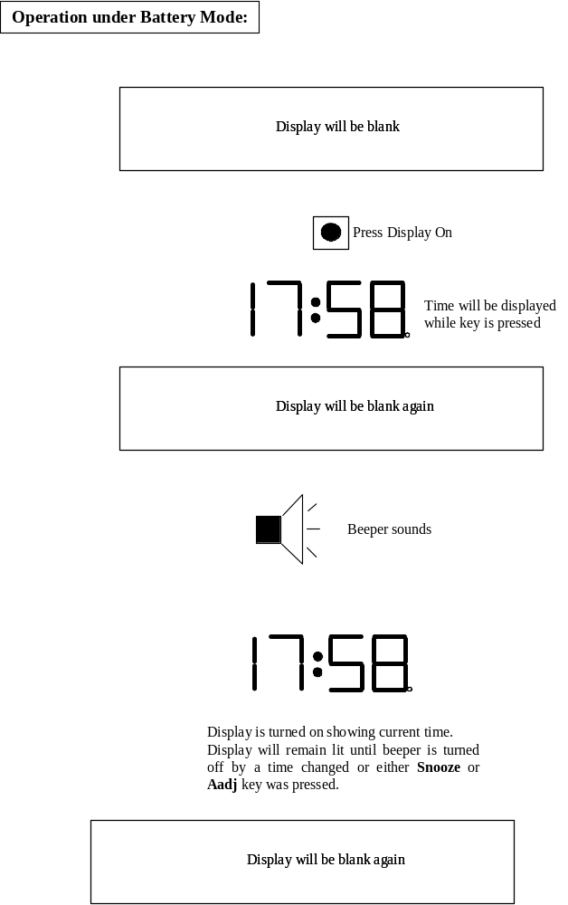

Fig. 10
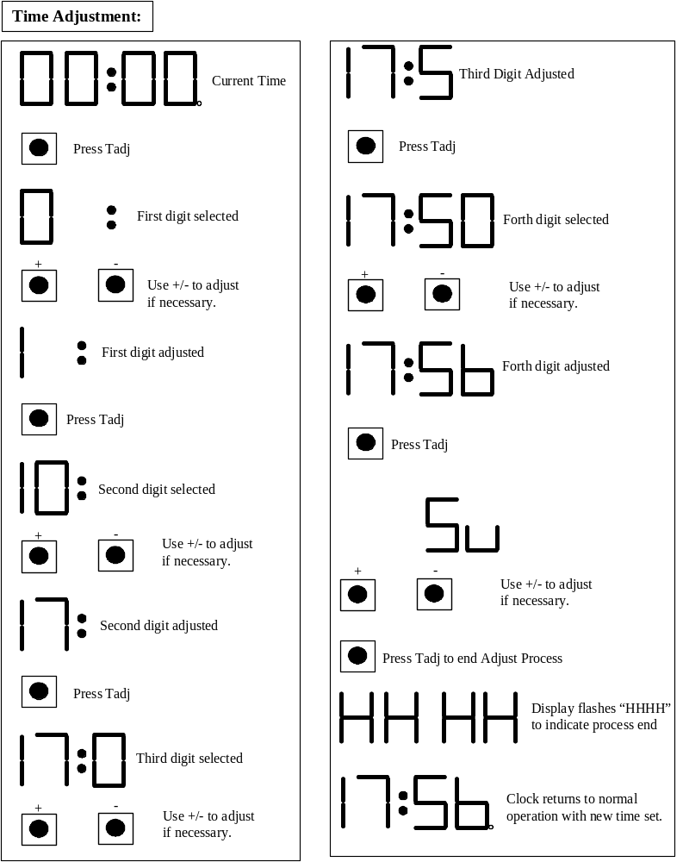

Fig. 11

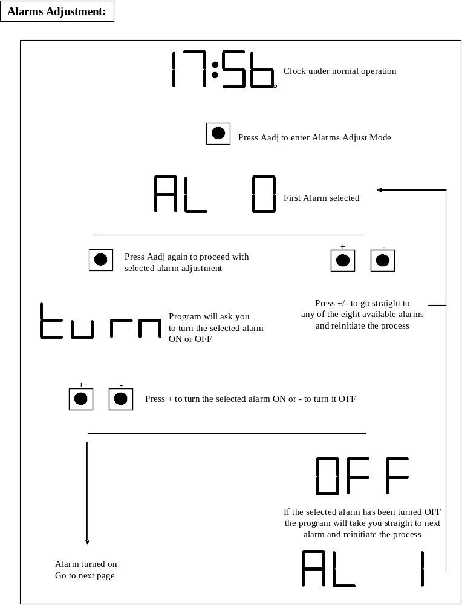

Fig. 12

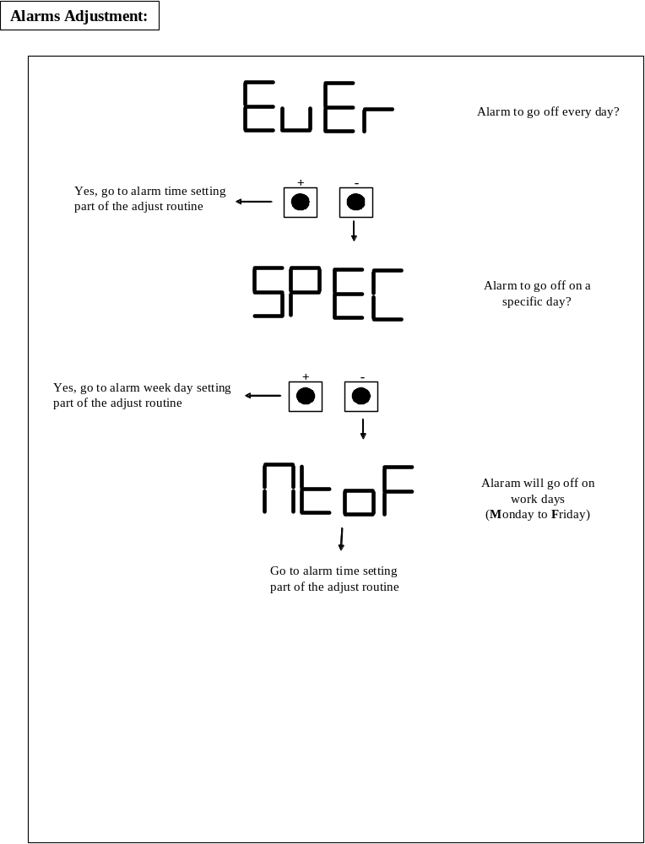

Fig. 13
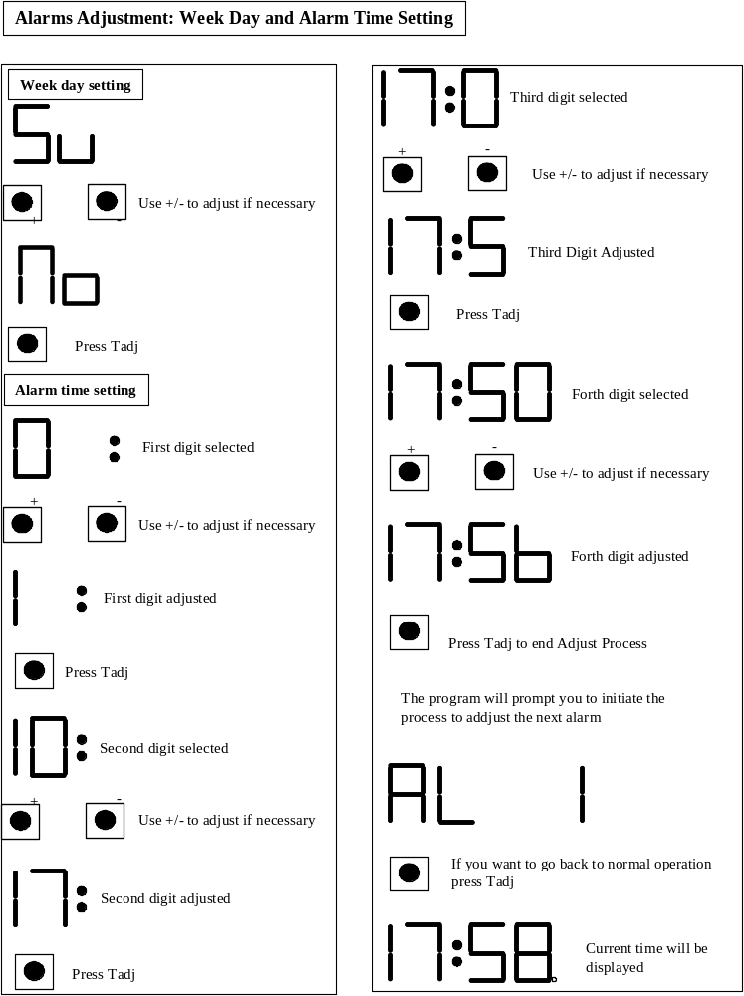

Fig.14

Appendix A: Using the PIC16F628 in the Digital Alarm Clock

The PIC16F628 is another 18-Pin microcontroller from Microchip. It’s very similar to the PIC16F84A. Correctly configured it may work under the same pin configuration. The PIC16F628A has more Program and Data memory so, it may carry more code and more data.

The author has developed the code to make the Digital Alarm Clock to operate with the PIC16F628. That will allow future expansions on the number of alarms and/or the inclusion of features like temperature reading, etc…

At this time the PIC16F628 version adds two new extra features which provide the user a means to make a rough adjustment to the clock’s time base and choose between 3 different snooze delays.

Both routines described below are executed as part of the clock’s main initialization sequence. This takes place the first time you turn the clock on.

Once in operation, in order to force the main initialization sequence to run again, you should turn the clock off with the back-up battery disconnected*, wait some time (10 to 20 seconds) for the power supply capacitor complete discharge and turn it back on.

a. Coarse adjustment of the time base:

As we all know the quartz crystal used is not 100% accurate. It presents a tolerance of approximately +/-100ppm on its basic oscillation frequency. So, the time base may oscillate at any frequency between 4,000,100Hz or at 3,999,900Hz. This tolerance will make the clock faster or slower than it should really be.

This version allows the user to choose between three operating modes:

- Clock is OK and no adjustments should be made to the time base (clocks accuracy is equal or close to what was mentioned in the first page of this document).
- Clock is faster than it should be. User will be able to notice that after 1 or 2 weeks of operation comparing the clock’s time to a another reliable clock that was used as a reference (user will note that the clock is a few seconds ahead).
- Clock is slower than it should be. User will also notice that after 1 or 2 weeks of operation.

The figure a1 shows sequence to select one of the three possible adjustments for the time base

As mentioned above this is a rough adjustment (you will never be able to reach 100% of accuracy) but is enough to keep the clock close to the reported accuracy mentioned in the first page of the document.

b. Selection of Snooze function delay duration:

You’ll be able to select one of three delay duration for the Snooze function:

- Standard Delay (S): 5 minutes.
- Long Delay (H)....: 10 minutes
- Short Delay (L).....: 1 minute

Figure a2 shows the sequence to select the desired delay.

Other than this, the clock operates exactly in the same way described for the PIC16F84A version.

* The battery disconnection is necessary to cause the microprocessor shutdown.
